USE-ME-D: professional training course
FORMATIVE EVALUATION
The manufacturer is required by IEC 62366-1:2015 to establish and maintain a user interface evaluation plan to guide formative evaluations the formative EVALUATION, as defined in IEC 62366 – 1 clause 3.7, is a user interface evaluation with the intent to explore user interface design, strengths, weakness and unanticipated use errors during medical devices development (i.e. during their “formation”) rather than when they are considered complete. It is a plan of tests and different techniques with the aim to “filter-out" user interface design shortcomings that could induce potentially harmful use errors and it points out opportunities for improvement.
Formative evaluation also can focus on any aspect of user interaction with a medical device, including interactions influencing user satisfaction and those that could affect a medical device’s commercial success.
It is an iterative activity and follows a “Spiral Model” approach, which means that it is performed several times (“iteratively”) during the design and development of the medical device following a cycle access-design-build (Figure 1).
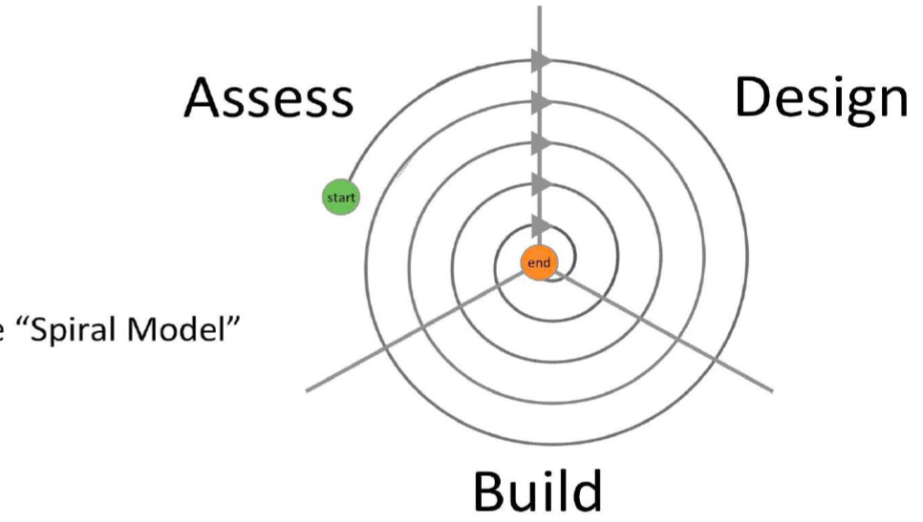
Figure 1: The “Spiral Model” of the formative evaluation depicting the iterative cycle of exploration performed by manufacturers in order to point out user interface design, strengths, weakness and unanticipated use errors during medical devices development.

This cycle includes tasks or hazard-related use scenarios in which use errors could occur and help to determine if the risk controls designed into the medical device have been successful. It can reveal previously unrecognized use-related hazards and use errors and helps manufacturers identify new critical tasks, user interaction problems and implement effective solutions.
It is a best practice to perform the formative evaluation prior to summative evaluation and it should be initiated early in the medical device research and development cycle.
There are number of methods available to conduct formative evaluations. the most commonly used methods are various types of reviews (expert reviews, standards reviews, heuristic analyses), cognitive walkthroughs and usability tests
The appropriate number of formative evaluations depends on many factors including the medical device’s complexity, the potential for use errors that could be harmful, and the development schedule and budget, as formative evaluations tests such as expert reviews, can be conducted quite cost effectively, more extensive user interface evaluations can require greater resources (i.e. time, money, staff, material, premises, test participants, etc.). To be conservative, manufacturers can plan to conduct at least 2 to 3 formative evaluations.
Although formative evaluations are generally small-scale and informal compared to a summative evaluation, they tend to grow larger and more formal as a design evolves from an early concept to a production-equivalent prototype.
At the latter stage of user interface design, formative evaluation enables the manufacturer to determine whether the medical device meets safety, usability, acceptable criteria, user and business needs and ultimately supports successful summative evaluation of the medical device.
Results of the formative evaluation should be documented in a test report supported by raw and processed data sets and, if collected, video recordings and photographs of the test sessions. These data can include customer preference survey responses, design shortcomings identified during testing, usability test participants’ comments, made while performing hands-on tasks as well as upon reflection on their task performance afterward and usability test participants’ ratings and rankings pertaining to hands-on tasks, specific medical device characteristics and the medical device in general.
Therefore, the formative evaluation plan helps to make manufacturers aware of resource needs and to allocate necessary resources well enough in advance. it inform them on various types of design needs and support medical device concept development, and refinement. It is an essential step in the usability engineering process.

